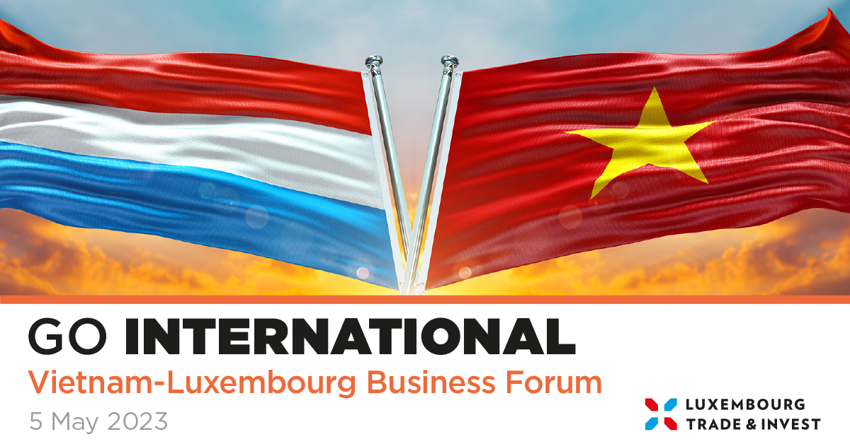
Hotel Park Hyatt Saigon

PROGRAM

09:00 – 09:30 | Registration & Coffee
09:30 – 10:00 | Welcome Addresses  - Nguyen Hong Dien, Minister of Industry and Trade of Vietnam  - Xavier Bettel, Prime Minister of Luxembourg
10.00 – 10:10 | Signing of the MoU between the Chamber of Commerce and Industry of Vietnam and the Luxembourg Chamber of Commerce
10:10 – 10:40 | Luxembourg Economy: Innovation in Times of Change  - Lex Delles, Minister for Small and Medium-Sized Enterprises and Minister for Tourism of Luxembourg  - Fernand Ernster, President - Luxembourg Chamber of Commerce
10:40 – 11:00 | Presentation by the Chamber of Commerce and Industry of Vietnam
11:00 – 11:45 | Workshop: Bilateral Cooperation in Logistics between Luxembourg and Vietnam achieved through top class Supply Chains  Introduction and Moderation by Malik Zeniti, Director, Luxembourg Cluster for Logistics  - Hans Kelderman, CEO, 2 Point 0  - Kevin Shek, Vice-President, Asia and Pacific, Cargolux Airlines International  - Patrick Neumann, CEO Multigone  - Alexander Munk Olsen, Vice-President FM & Commercial, ITL Corporation  - Tom Tabouring, Senior Commercial Manager, ITL Corporation  - Sven Mueller, Managing Director, CEVA Logistics
11:45 – 12:00 | Testimonials
12:00 – 14:00 | Networking lunch

